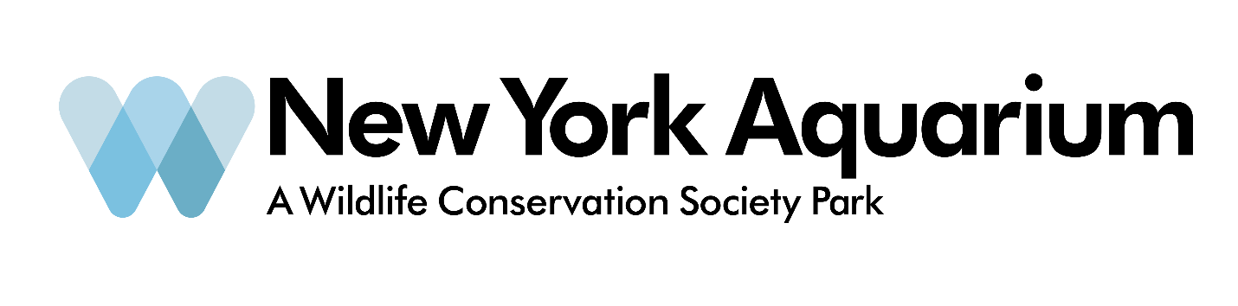
Grab a bite to eat in the neighborhood!

Near Coney Island:
Surf City Pizzeria, 837 Surf Ave Brooklyn, NY 11244
Gargiulo’s Restaurant, 2911 W 15th St Brooklyn, NY 11224

Near Sheepshead Bay:
Nargis Café, 2818 Coney Island Ave Brooklyn, NY 11235
Tsob-Tsobe, 2817 Coney Island Ave Brooklyn, NY 11235-5015
KarVér, 1809 Emmons Ave Brooklyn, NY 11235

